SECURE CODING ASSIGNMENT-7

~ prof. Sibi chakravarthy

**Name;** D. Megha Sri Satya Sai

**Registration no;** 17bcd7092

**LAB EXERCISE-7**

**What is the use of obfuscating code??**

Obfuscation is the practice of making something difficult to understand. Programming code is often obfuscated to protect intellectual property and prevent an attacker from reverse engineering a proprietary software program. Obfuscation may involve encrypting some or all of the code, stripping out potentially revealing metadata, renaming useful class and variable names to meaningless labels or adding unused or meaningless code to an application binary. A tool called an obfuscator can be used to automatically convert straight-forward source code into a program that works the same way, but is much harder to read and understand.

**Obfuscating python code**

* **Sample PythonCode**

# Python program to check if the input number is prime or not

num = 407

# take input from the user

# num = int(input("Enter a number: "))

# prime numbers are greater than 1

if num > 1:

# check for factors

for i in range(2,num):

if (num % i) == 0:

print(num,"is not a prime number")

print(i,"times",num//i,"is",num)

break

else:

print(num,"is a prime number")

# if input number is less than

# or equal to 1, it is not prime

else:

print(num,"is not a prime number")

**Screenshot of python code:**  
 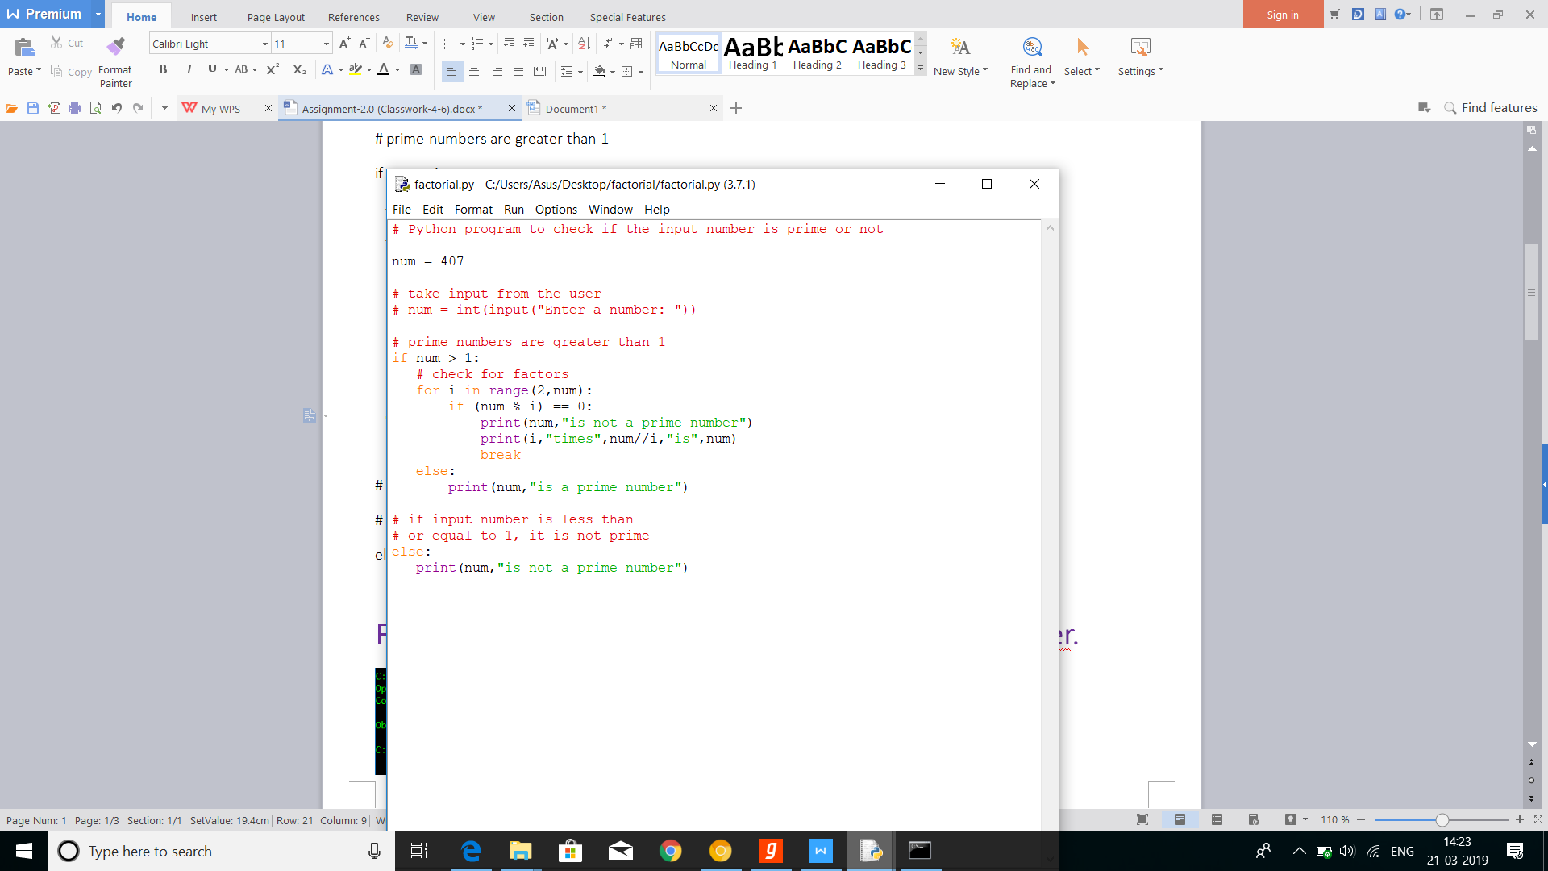

* **For this, we will need to create an executable by installing PyInstaller.**

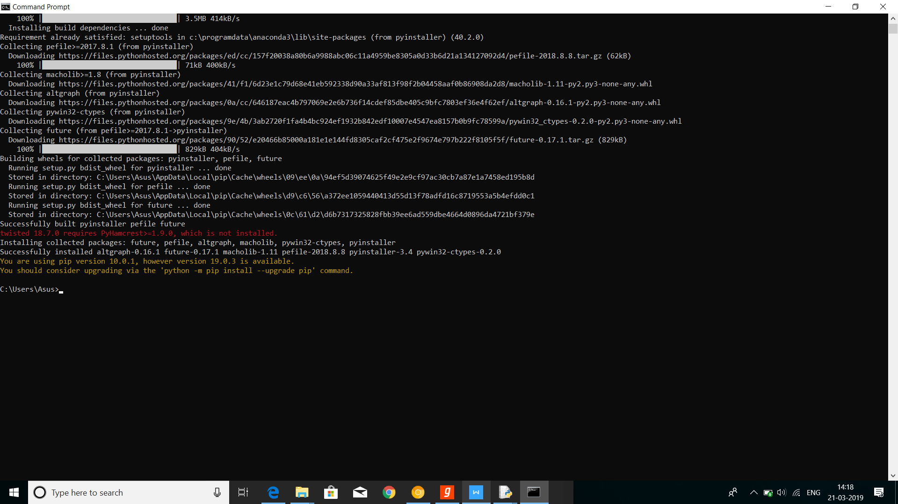

* **Now Using Opy, Obfuscating the code we need to install opy**

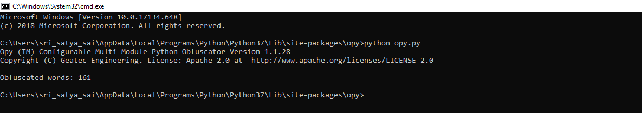

* So now the number of obfuscated words are 161
* **Now you need to paste your code and your code in same folder**

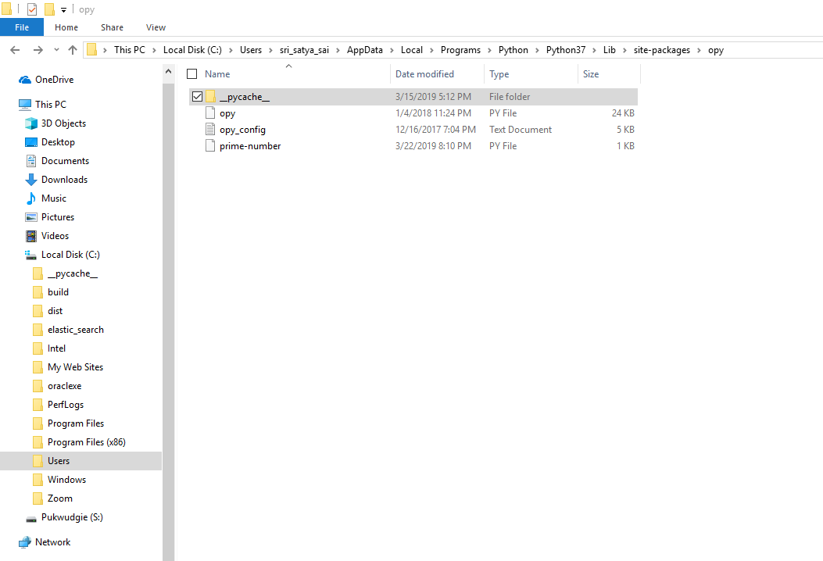

* **Now run the opy python file**

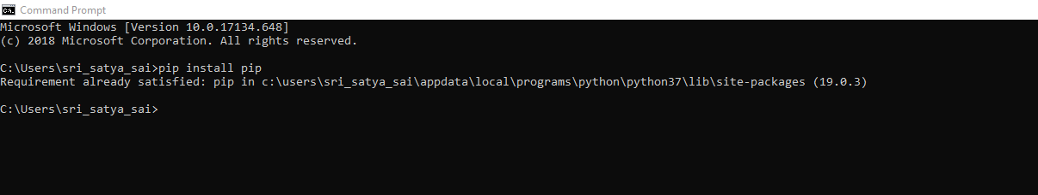

* **Now search for the obfuscated python code and run the code then you will get the obfuscated code**

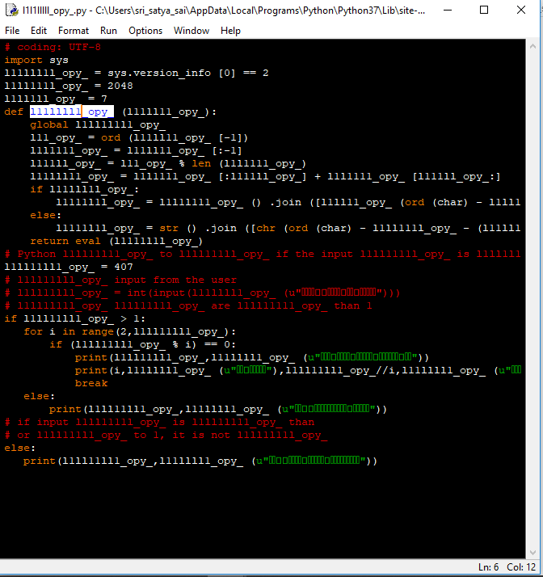

* **For both the executables, we use immuntiy debugger**

